**Acids, Bases, and the pH Scale (Worksheet)**

**Q.1.** Fill in the blanks with suitable words.

**a)** The ______________ measures how acidic or basic a substance is.

**b)** pH scale ranges from _________ to ___________.

**c)** A solution has a pH of 7, it's _____________.

**d)** A pH less than 7 is an _________, with ____________ numbers indicating stronger acids.

**e)** A pH greater than 7 is a _________, with ___________ numbers indicating stronger bases.

**Q.2.** Fill the blanks with following words to identify ranges of the pH scale.

|  |  |  |
| --- | --- | --- |
| * neutral | * acidic | * basic |

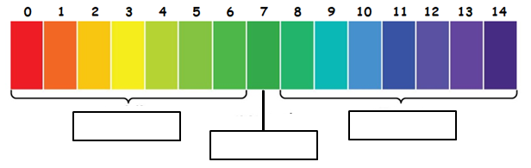

**Q.3.** Fill in the blanks with suitable words in the table below.

|  |  |
| --- | --- |
| **Properties of Acids** | **Properties of Bases** |
| * Acids produce ________________ ions in solution. * Acids taste __________. * Acids turn litmus paper ________. * Acids feel ________________. * Acids ______________ electricity. | * Bases produce ________________ ions in solution. * Bases taste ___________. * Bases turn litmus paper __________. * Bases feel _______________. * Bases _____________ electricity. |

**Q.4.** Use the words in the box below to label the following acid-base reactions.

|  |  |
| --- | --- |
| * Water | * Base |
| * Acid | * Salt |

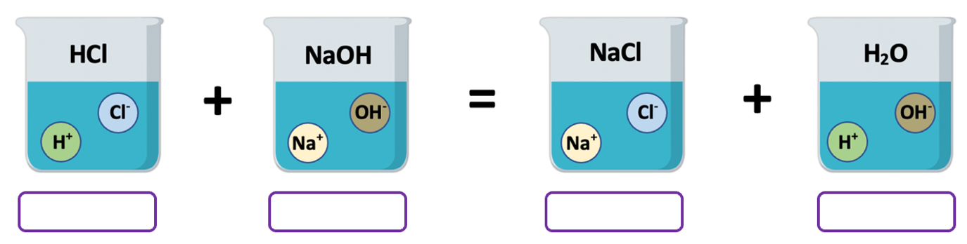

**Q.5.** Write **T** or **True** if the statement is true; write **F** or **False** if the statement is false.

_________ **1**. Pure water is neutral which means that it has a pH of 0.

_________ **2.** According to Arrhenius, an acid produces H+ ions when dissolved in water.

_________ **3.** According to Arrhenius, a base produces OH- ions when dissolved in water.

_________ **4**. Acids are sometimes called alkalis.

_________ **5.** pH is a measure of hydrogen (H+) ions.

_________ **6.** A solution with a pH of 9 would be acidic.

_________ **7**. In the Bronsted–Lowry definition, an acid is a proton donor.

**Q.6.** Which pH value indicates the **most acidic solution**?

|  |  |  |  |
| --- | --- | --- | --- |
| a) 7 | b) 2 | c) 5 | d) 11 |

* Use the pH scale below to answer the next three questions. *(Questions 7 - 8 - 9)*

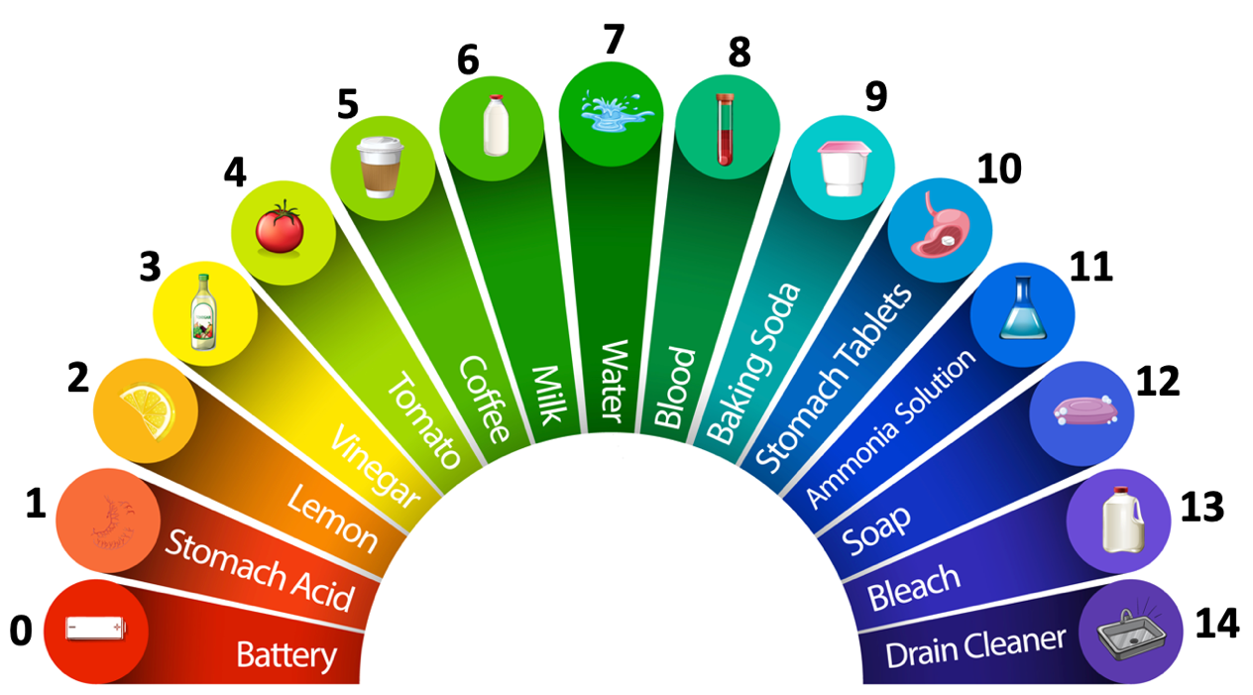

**Q.7.** Which of the following is an **acid**?

|  |  |
| --- | --- |
| a) Lemon | b) Water |
| c) Ammonia Solution | d) Bleach |

**Q.8.** Which of the following items would turn red litmus paper blue?

|  |  |
| --- | --- |
| a) Milk | b) Vinegar |
| c) Baking Soda | d) Tomato |

**Q.9.** Which of the following would be considered the **strongest base**?

|  |  |
| --- | --- |
| a) Blood | b) Soap |
| c) Baking Soda | d) Drain Cleaner |

**Q.10.** What is the name of the chemical reaction between an acid and a base?

|  |  |
| --- | --- |
| a) Decomposition | b) Neutralization |
| c) Combustion | d) Precipitation |

**Q.11.** Which reacts with metals to form H2 gas?

|  |  |
| --- | --- |
| a) acids | b) bases |
| c) water | d) salts |

**Q.12.** Which of the following is a **base**?

|  |  |
| --- | --- |
| a) H2SO4 | b) HNO3 |
| c) HCl | d) NaOH |

**Q.13.** Which of the following is an **acid**?

|  |  |
| --- | --- |
| a) Mg(OH)2 | b) Al(OH)3 |
| c) H2CO3 | d) NH4OH |

**Q.14.** Which of the following is wrongly named?

|  |  |
| --- | --- |
| a) HNO3: Nitric acid | b) H2SO4: Phosphoric acid |
| c) Ca(OH)2: Calcium hydroxide | d) KOH: Potassium hydroxide |

**Q.15.** What will be the **X** in the following equation?



|  |  |
| --- | --- |
| a) KNO3 | b) Na2SO4 |
| c) H3PO4 | d) K2SO4 |

**Q.16.** In the Bronsted–Lowry definition, a base is a(n) _____________ acceptor.

|  |  |
| --- | --- |
| a) proton | b) electron |
| c) neutron | d) nucleon |

**Q.17.** A solution with a pH of 8.0 is __________________.

|  |  |
| --- | --- |
| a) weakly acidic | b) strongly acidic |
| c) weakly basic | d) strongly basic |

**Q.18.** An acid-base reaction is shown below.



Which of the following is a **salt**?

|  |  |
| --- | --- |
| a) H2SO4 | b) Ca(OH)2 |
| c) CaSO4 | d) 2H2O |